Exercises on Loops and Data Structures

[1] – Using Loops Only, Write Functions that will print the following shapes.
Section A
Enter the number of stars: 6
*
**
***
****
*****
******

Section B
Enter the number of stars: 6
******
*****
****
***
**
*

Section C
Enter the number of stars: 6
*
***
*****
*******
*********
***********

[2]
Write a Python function that will read in a list and return its sum, the smallest value, the largest value

[3] Code Challenge – 1

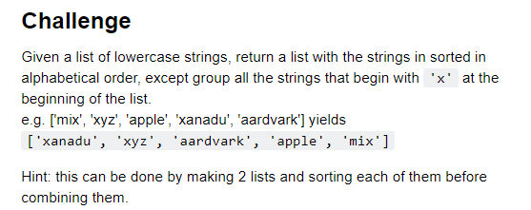
Function = sorted
[4] Code – Challenge – 2

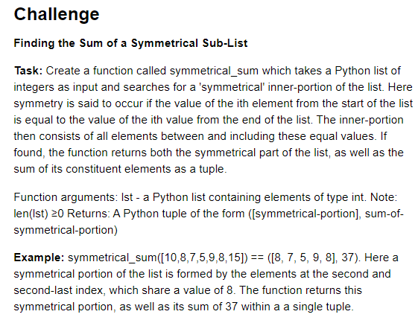

[5] Code Challenge – 3

